MINI PIANO USING ARDUINO

Course: workshop
Submitted By: Vinod kumar
Department: computer system engineering
Cms: 133-25-0026
Submitted To: irfan younis mughal
Session: 2k25

2. Acknowledgment
I would like to thank my instructor for providing guidance throughout this project. I am also thankful to my classmates and friends for their support. This project helped me learn practical skills such as circuit building, Arduino programming, and teamwork.

3. Introduction
The Mini Piano Project is a simple electronic musical instrument built using an Arduino, 8 push buttons, and a buzzer. Each push button represents a musical note. When a button is pressed, the Arduino generates a specific frequency that produces a tone through the buzzer.
This project demonstrates basic electronic components, digital input handling, and sound generation using Arduino.

4. Objectives
- To learn the basics of Arduino and its digital input pins.
- To design a simple electronic musical instrument.
- To understand how sound frequencies create musical notes.
- To improve practical skills in circuit assembly and coding.
- To develop a fun and interactive hardware project.

5. Table of components

Sr | Component Name | Quantity | Description
1 | Arduino Uno | 1 | Microcontroller board
2 | Push Buttons | 8 | Used to trigger musical notes
3 | Buzzer / Speaker | 1 | Produces sound output
4 | Resistors (10kΩ) | 8 | Pull-down resistors
5 | Jumper Wires | — | For connections
6 | Breadboard | 1 | Circuit assembly
7 | USB Cable | 1 | For uploading code

6. Circuit Diagram (Description)
- Each of the 8 push buttons is connected to digital pins 2–9 on the Arduino.
- One side of each button goes to 5V.
- The other side goes to the Arduino pin and also to a 10kΩ resistor → GND (pull-down setup).
- The buzzer is connected to pin 10 and GND.
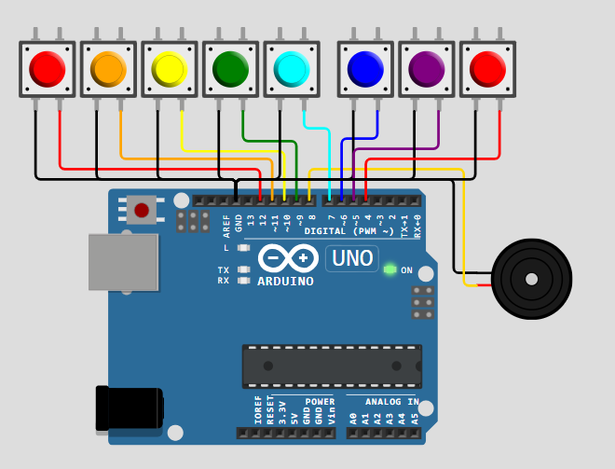

7. Working Principle
- When a button is pressed, it sends a HIGH signal to the Arduino pin.
- Arduino reads which button is pressed using digitalRead().
- The program plays a specific tone frequency for each button.
- The buzzer produces sound based on the tone() function.
- Releasing the button stops the sound.

8. ardiuno code

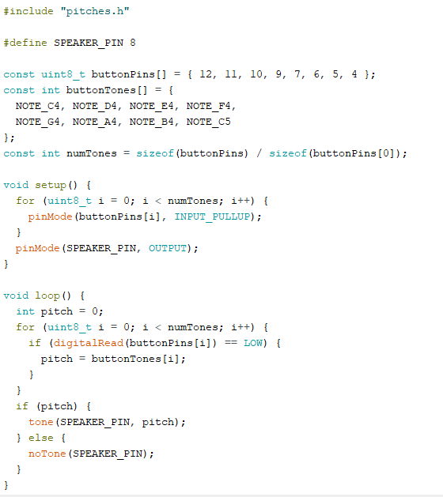

12. Conclusion
This project successfully demonstrates how an Arduino can be used to create a mini piano using push buttons and a buzzer. Through this project, I learned circuit designing, coding basics, and how musical notes work. The project is simple but highly educational for beginners.

